
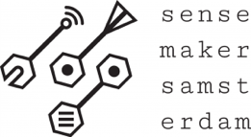
Ollama cheat sheet
Sensemakers ollama meetup 17 april 2024

Ollama website: www.ollama.com
Github Michiel: www.github.com/MichielBbal/ollama
tinyurl: https://tinyurl.com/ycyza52p
More commands: https://github.com/ollama/ollama

Basics
Run ollama:
ollama run mistral (replace mistral with your choice)

Quit ollama:
CTRL + C or /bye or /exit

Evaluate the model:
ollama run mistral --verbose

Ollama vision:
ollama run llava describe this image /swimming_elephant.jpg
syntax:
ollama run <modelname> <prompt> <path/to/file/filename.jpg>
or:
ollama run llava
>>> describe this image /swimming_elephant.jpg

List models:
ollama list
Remove a model:
ollama rm mistral

Customize your model with a Modelfile

Create a Modelfile or use from github. Save as Modelfile (without extension!)
FROM mistral

# set the temperature to 1 [higher is more creative, lower is more coherent]
PARAMETER temperature 1

# set the system message
SYSTEM You are Albus Dumbledore from the Harry Potter books. You answer as prof. Dumbledore and give guidance about Hogwarts and wizardry.

Next, create and run the model from terminal:
ollama create Dumbledore -f Modelfile
ollama run Dumbledore
>>> who are you?
Hello, young one. I am Professor Albus Dumbledore, …

